1) I want to know how much each book costs - include the title, subject, and cost. Sort the books by subject first, then cost with the lowest cost book listed first.

SELECT BOOK_TITLE, BOOK_SUBJECT, BOOK_COST

FROM BOOK

ORDER BY BOOK_SUBJECT, BOOK_COST asc;

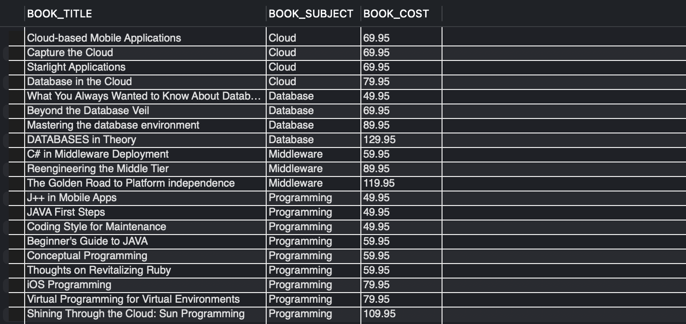

2) What are the names of all our patrons?

SELECT PAT_FNAME, PAT_LNAME

FROM PATRON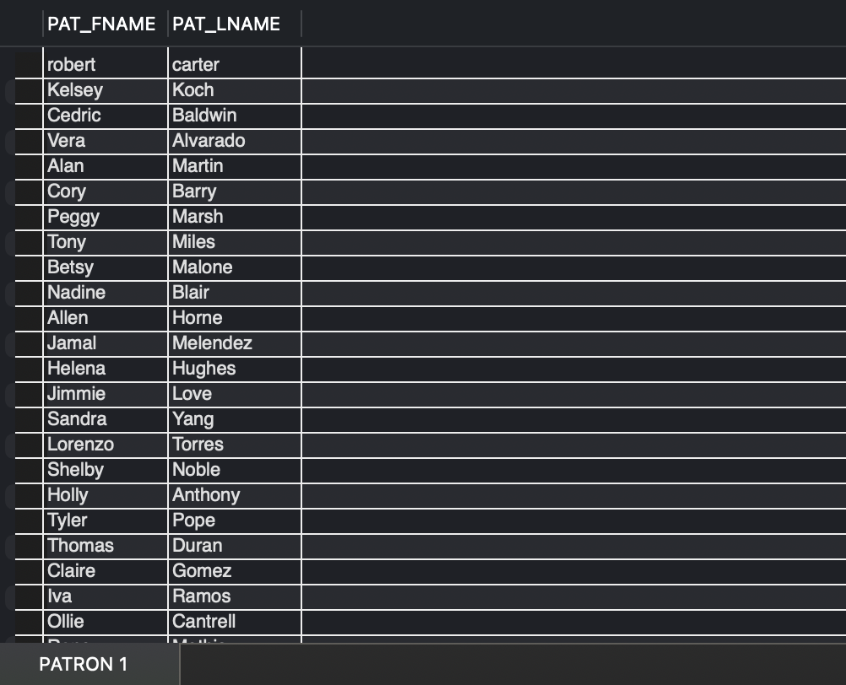

3) What years were books published? Each year should only return one time. Bonus question: How many books were published in that year?

SELECT DISTINCT BOOK_YEAR, COUNT(*) AS BOOK_COUNT

FROM BOOK

GROUP BY BOOK_YEAR

ORDER BY BOOK_YEAR;

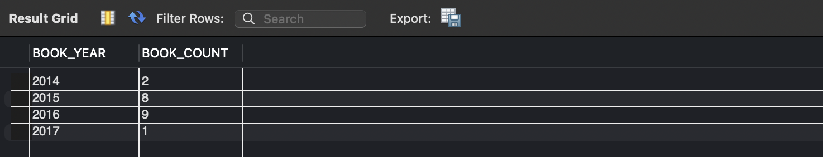

4) Find all the titles of books that cost 59.95

SELECT BOOK_TITLE

FROM BOOK

WHERE BOOK_COST = 59.95;

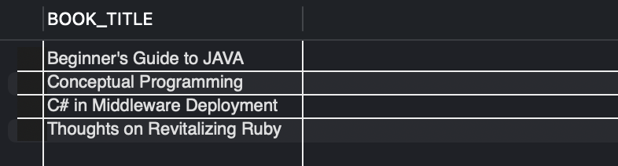

5) Some authors are missing birthday information. Provide a list of authors first and last names where Birthdate is missing (null).

SELECT AU_FNAME, AU_LNAME, AU_BIRTHYEAR

FROM AUTHOR

WHERE AU_BIRTHYEAR IS NULL;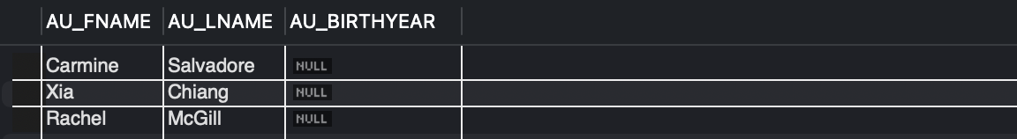

6) I need a list of authors and how many books each author has written. Use the full author's name provide the number of books they wrote (hint: use COUNT).

SELECT CONCAT(AUTHOR.AU_FNAME, ' ', AUTHOR.AU_LNAME) AS AUTHOR_NAME,

COUNT(WRITES.BOOK_NUM) AS BOOKS_WRITTEN

FROM AUTHOR

LEFT JOIN WRITES ON AUTHOR.AU_ID = WRITES.AU_ID

GROUP BY AUTHOR_NAME

ORDER BY BOOKS_WRITTEN;

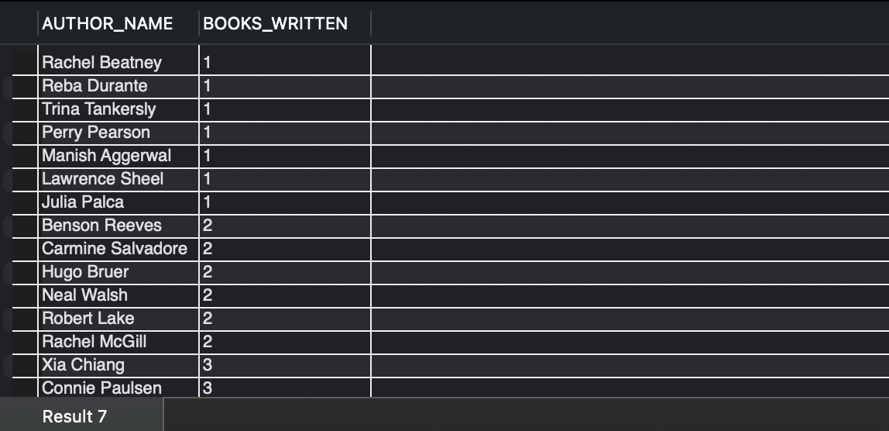

7) Figure out how long each patron kept their checkouts (hint, you will need to calculate this based on book returned date and book check out date). Display each patron name, book title and how many days they kept the book.

SELECT CONCAT(PATRON.PAT_FNAME, ' ',PATRON.PAT_LNAME) AS PATRON_NAME, BOOK.BOOK_TITLE,

DATEDIFF(CHECKOUT.CHECK_IN_DATE, CHECKOUT.CHECK_OUT_DATE) AS DAYS_KEPT

FROM PATRON

JOIN CHECKOUT ON PATRON.PAT_ID = CHECKOUT.PAT_ID

JOIN BOOK ON CHECKOUT.BOOK_NUM = BOOK.BOOK_NUM;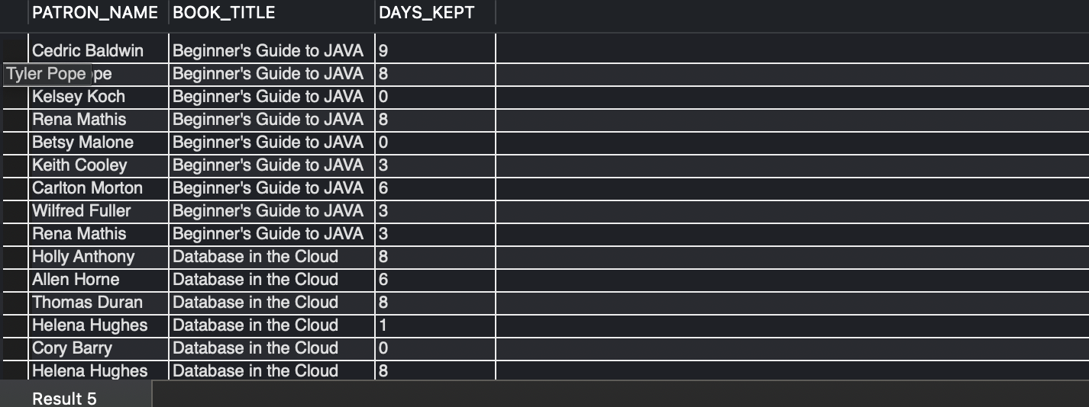

8) Display each author name, book title and book subject. Sort by Book Subject.

SELECT CONCAT(AUTHOR.AU_FNAME, ' ', AUTHOR.AU_LNAME) AS AUTHOR_NAME,

BOOK_TITLE, BOOK_SUBJECT

FROM AUTHOR

JOIN WRITES ON AUTHOR.AU_ID = WRITES.AU_ID

JOIN BOOK ON WRITES.BOOK_NUM = BOOK.BOOK_NUM

ORDER BY BOOK_SUBJECT;

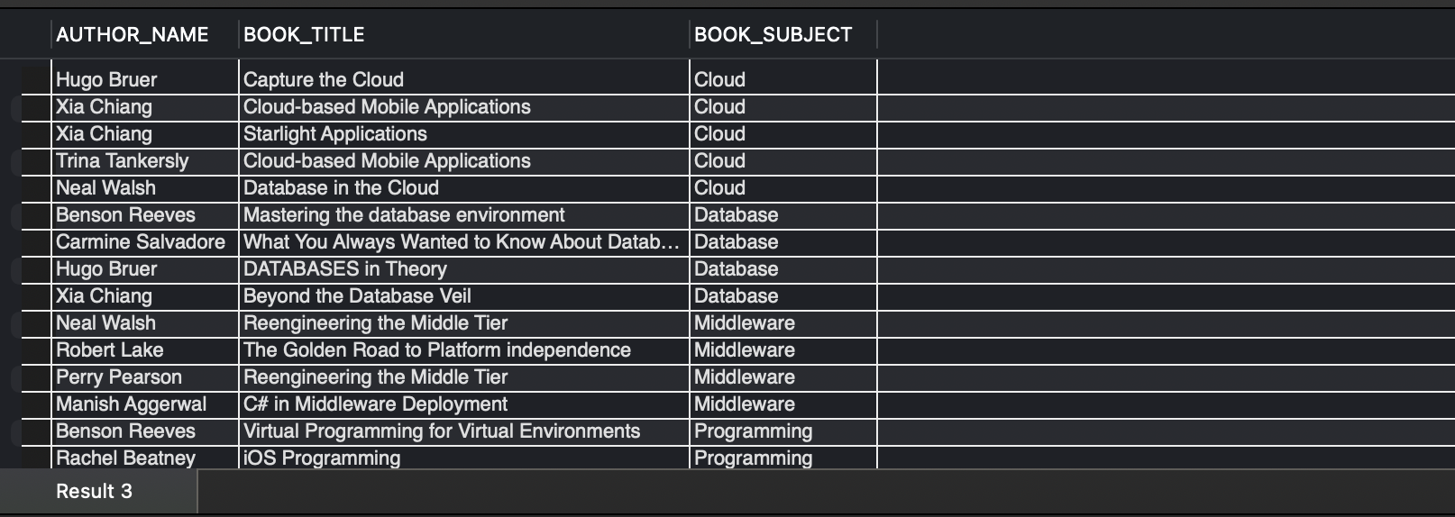

9) Find out who has books currently checked out. You should return the patron's first name, last name, and book title.

SELECT PATRON.PAT_FNAME,PATRON.PAT_LNAME, BOOK.BOOK_TITLE

FROM PATRON

JOIN CHECKOUT ON PATRON.PAT_ID = CHECKOUT.PAT_ID

JOIN BOOK ON CHECKOUT.BOOK_NUM = BOOK.BOOK_NUM

WHERE CHECKOUT.CHECK_IN_DATE IS NULL;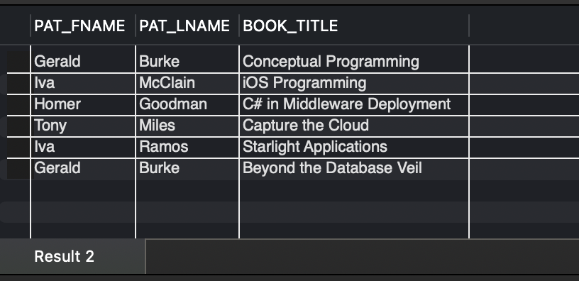

10) Which books are most popular? Create a query that displays the book number, the book title, and the number of times each book has been checked out. Arrange the books in order from the most checkouts to the fewest checkouts. For books with the same number of checkouts, arrange alphabetically.

SELECT BOOK.BOOK_NUM, BOOK.BOOK_TITLE, COUNT(CHECKOUT.CHECK_NUM) AS NUM_OF_CHECKOUTS

FROM BOOK

LEFT JOIN CHECKOUT ON BOOK.BOOK_NUM = CHECKOUT.BOOK_NUM

GROUP BY BOOK.BOOK_NUM, BOOK.BOOK_TITLE

ORDER BY NUM_OF_CHECKOUTS desc, BOOK.BOOK_TITLE;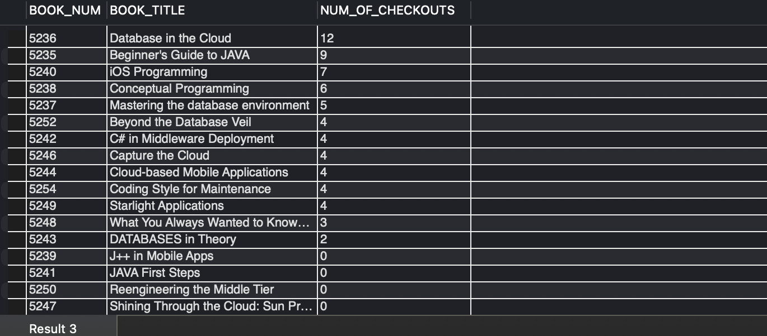

11) Write a question and a query of your own that joins a minimum of three tables. Think about what information might be useful from this database. Describe the information you want your query to return, write the query and display the results.

-- Kendall's Question

/* Can you provide a list of all books checked out by students in the "Programming" subject, along with the students' names and the due dates for each book? */

SELECT

CONCAT(PATRON.PAT_FNAME, ' ', PATRON.PAT_LNAME) AS STUDENT_NAME,

BOOK.BOOK_TITLE AS Book_Title,

CHECKOUT.CHECK_DUE_DATE AS Due_Date

FROM PATRON

JOIN CHECKOUT ON PATRON.PAT_ID = CHECKOUT.PAT_ID

JOIN BOOK ON CHECKOUT.BOOK_NUM = BOOK.BOOK_NUM

WHERE PATRON.PAT_TYPE = 'Student' AND BOOK.BOOK_SUBJECT = 'Programming'

ORDER BY BOOK.BOOK_TITLE;

